Star Cell Bio Exercise 1

Focus on membranes, transmembrane proteins

Techniques: Western blot, FACS, microscopy

Question 1

Start with proteins (#?)

A

B

C

D

E

1. Localization

Using microscopy images of gfp tagged protein (vector transfected into cells), identify localization of protein. Can use controls as examples of where

Possibilities:

* PM
* Nuclear envelope
* Nucleus
* Cytoplasm
* ER
* Golgi
* Endosomes

**-mislocalization? See if too long with that**

**Question 2**.

Look at transmembrane orientation of proteins F and G

Similar to ex. In p sets. **Will require some explanation so method is clear**, including a diagram of protein with myc/ha on diff ends and maybe some examples of protein in cell and where myc/ha end up in different cases.

a)WB

- digest with protease k to chew up protein outside cell – cant get into cell

- lyse cells, blot with conjugated anti-myc andtibody, reprobe with conjugated anti-HA antibody.

* If protein shows both Myc and HA signal, both ends of protein inside cell
* If protein shows only Myc sicnal, N terminal end inside cell, C terminal end outside cell
* If protein shows only HA signal, C terminal end inside cell, N terminus outside cell
* If protein shows not singal, both ends outside cell

If you tell them how many transmembrane domains, draw pic to represent orientation

b) flow cytometry

incubate cells w/ anti-HA and anti Myc antibody, (is secondary fluorescent antibody fluorescent to increase signal??)

perform flow cytometry, 2 color

* Quad 1; no myc or ha - both ends inside cell
* Quad 2; low myc high HA - protein shows only HA signal, n terminal end inside cell, c terminus outside cell
* Quad 3; low HA high myc - protein shows only Myc sicnal, c terminal end inside cell, n terminal end outside cell
* Quad 4; high HA high myc protein shows both Myc and HA signal, both ends of protein outside cell

c. If you tell them how many transmembrane domains, draw pic to represent orientation

d. advantages/disadvantages of each method. When would you use one over the other?

interpretations from both experiments should agree - but actual raw results are opposite (in one case measuring signal inside cell, in the other, measurieng signal outside cell).

Diff ways of getting the same result (ie measure inside vs outside cell)

e. If you have only 2/3/ what possibilities can you have ? or just do 2 proteins, with diff number of transm. Domains so you get all possibilities

Question 3

Now, Look in more detail at protein A and mutants. (egfr??

There will be WT cells, mutants:

Mut 1 with a mutation in internalization adapter phosphorylation site = this protein will be gain of function with higher levels of signaling and lower levels of internalization to shut off signaling. Adaptin binding at phosphorylated EGFR site in signaling domain induces internalization. Seems like degredation happens from clatherin independent internalization… let’s say this mutation decreases internalization and therefore decreases the attenuation of signal

mut 2 wrong orientation in plasma membrane – can’t signal because ligand binding and activation sites are in the wrong places. Flipping can occur if the charges of amino acids flanking the transmembrane domain are altered

To characterize mutants you will look at:

1. expression levels and size (WB),
2. localization (microscopy),
3. Orientation (WB or fcs),
4. signaling (WB for phosphorylation of EGFR and downstream molecule ie grb2, mapk),
5. internalization (flow cytometry with anti-egfr fluorescent antibody at time points after addition of ligand).

A. expression and size of mutant proteins

Run WB to compare size and protein expression (entire cell). Protein expression similar between WT and mutants therefore not an issue with protein expression.

Size : probably the diff. in size will be to small to see clearly on WB if it's a small deletion, pt mutations are invisible. So size will probably look the same.

B. Localization of mutants

express mutant cDNA tagged with GFP, look with microscopy at location of GFP expression (= mutant EGFR expression) in the cell

Results would be : all mutants still located to plasma membrane, therefore mutant phenotypes not due to improper subcellular localization

*Use GFP library for images: http://gfp-cdna.embl.de/index.html

*Also may want to do with and without ligand. Without ligand, in PM, upon addition of ligand, moves to endosomes (can see internalization). This may lead nicely into the question on internalization --- mut 1 wont move into cell.

Papers have pics but have difficulty finding one w/ control…

C. orientation of mutants

decide to check orientation of mutants and compare to WT (in question 2)

mut 3 will have incorrect orientation. Use same method as above w/ proteinase k and a myc/ha tagged cDNA vector derived from mutant gene.

D. singaling in mutants

look at phosphorylation state of EGFR (can identify the particular phosphorulation that results in sh2/grb2 binding), or downstream molecules. Expect the gof mutation will have high levels of phosphorylation (higher than WT, but this may not be visible on the WB), and mutants affecting signaling will have lower phosphorylation of downstream molecules and in case of flipped receptor, of the receptor itself too.

E. internalization of mutant protein

Both mutants wont be internalized either because flipped or because cant bind factors needed for internalization.

inhibitors of CME:

clathrin-mediated endocytosis has been inhibited by the use of monodansylcadaverine (MDC), potassium depletion, phenylarside oxide (PAO), cytosolic acidification, hypertonic shock (sucrose)or chlorpromazine

Papers on egfr

<http://www.jbc.org/content/273/52/35000.full>

Royston E. Carter and Alexander Sorkin

Fluorescent Protein Chimera

Growth Factor Receptor-Green

1998 paper

Microscopy images:

-pictures of EGFR localization in cell

-co-localization of EGF-TR and EGFR-GFP during endocytosis

-Dynamics of EGFR-GFP-containing endosomes in living cells

<http://www.jbc.org/content/288/21/14824.full?sid=5ae44e60-cb01-4b62-9f5a-35ff9ff1d3b9>

*Transforming Growth Factor-β1 (TGF-β1)-stimulated Fibroblast to Myofibroblast Differentiation Is Mediated by Hyaluronan (HA)-facilitated Epidermal Growth Factor Receptor (EGFR) and CD44 Co-localization in Lipid RaftsMay 24, 2013* The Journal of Biological Chemistry, *288, 14824-14838.*

-frap on egfr shows its not dynamic (v. low recovery) stays photobleached

-can compare this to controls, one of which is recovered quickly, one that is not dynamic – conclude wt is not dynamic

<http://www.jbc.org/content/284/25/17243.full?sid=3a7f2b6c-586a-4df2-bc77-948285e03f87>

Systems Biological Analysis of Epidermal Growth Factor Receptor Internalization Dynamics for Altered Receptor Levels*

Hannah Schmidt-Glenewinkel et al. 2009 jcb

-flow cytometry to measure dynamics of egfr internalization in presence of egf

<http://www.sigmaaldrich.com/life-science/cells-and-cell-based-assays/egfr-biosensor-cell-line.html#imaging>

sigma website: link to pub

<http://www.ncbi.nlm.nih.gov/pmc/articles/PMC3277729/#!po=5.76923>

nice pics of fluorescent egfp, shows movt from PM into cell w/ confocal microscopy in presence of egf ligand

<http://www.plosone.org/article/info%3Adoi%2F10.1371%2Fjournal.pone.0058148>

shows pics of egfr internalization and maybe an inhibitor?

<http://www.ncbi.nlm.nih.gov/pmc/articles/PMC2721002/>

inhibitors of CME:

clathrin-mediated endocytosis has been inhibited by the use of monodansylcadaverine (MDC), potassium depletion, phenylarside oxide (PAO), cytosolic acidification, hypertonic shock (sucrose)or chlorpromazine

<http://www.plosone.org/article/info%3Adoi%2F10.1371%2Fjournal.pone.0058148>

Internalization Mechanisms of the Epidermal Growth Factor Receptor after Activation with Different Ligands

Lasse Henriksen, Michael Vibo Grandal, Stine Louise Jeppe Knudsen, Bo van Deurs, Lene Melsæther Grøvdal

Cells were incubated with ligand (RnD Systems, Minneapolis, Minnesota). Cells were washed with ice-cold PBS, washed 5 minutes with an ice-cold acidic buffer (100 mM NaCl, 50 mM glycine, pH 2.5) to remove any remaining bound ligand, neutralized with ice-cold PBS and trypsinized on ice until detachment. Trypsin was neutralized by addition of soy bean trypsin inhibitor, and the detached cells were fixed for 15 minutes in ice-cold 2% paraformaldehyde. The amount of EGFR present at the cell surface was determined by labeling of the **unpermeabilized and fixed cells with an anti-EGFR antibody directly conjugated to FITC (AbD serotec, Oxford, UK) followed by flow cytometric analysis to quantify EGFR surface labeling.**

Alix/AIP1 Antagonizes Epidermal Growth Factor Receptor Downregulation by the Cbl-SETA/CIN85 Complex

Mirko H. H. Schmidt1,2, Daniela Hoeller2, Jiuhong Yu1, Frank B. Furnari3,4, Webster K. Cavenee3,4,5, Ivan Dikic2 and Oliver Bögler1,*

<http://mcb.asm.org/content/24/20/8981.full>

In the second approach, receptor internalization was measured by flow cytometry. Forty-eight hours after transfection with pTER-Alix and pEGFP-C1 cell monolayers of 293T or HeLa cells were incubated with 50 ng of EGF/ml at 37°C to induce internalization of EGFR. At various time points cells were harvested and blocked in 5% BSA-PBS for 30 min on ice. The amount of endogenous surface resident EGFR was detected by incubation with an anti-EGFR antibody, conjugated with phycoerythrin (BD Pharmingen) for 1 h at 4°C. Cells were washed with ice-cold PBS and analyzed with an Epics XL flow cytometer (Beckman-Coulter). For each sample 10,000 cells were analyzed and GFP-expressing cells were gated for determining the amount of EGFR at the plasma membrane. Mean fluorescence intensity of each sample was calculated with Expo 32 ADC software.

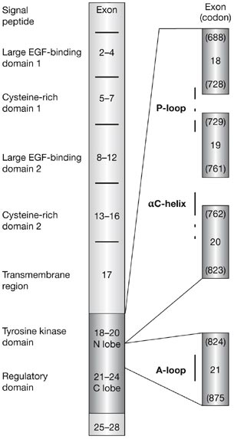

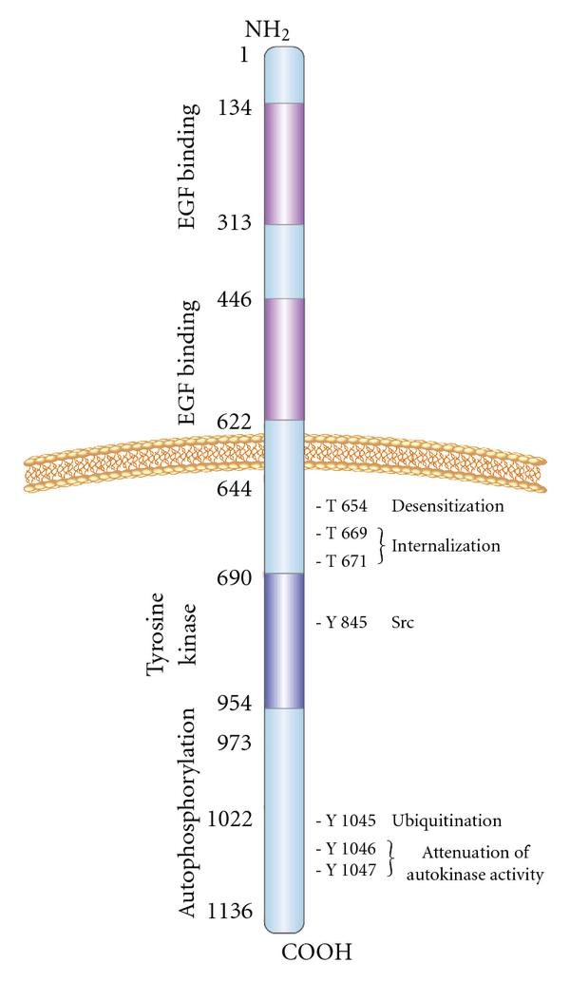

<http://www.hindawi.com/journals/jo/2010/568938/fig1/>

